Chest X-Ray Pneumonia Detection Using a Convolutional Neural Network
Project Report
GROUP MEMBERS
BLEVI EBENEZER ------ UEB3585525
(https://github.com/Bleviebenezer/-pneumonia-xray-cnn.git)

NASAMU DOODI ISSAKA ------ UEB35846

ABDULAI INSHAF ------ UEB3587625

1. Introduction
This project develops a binary image classification system that determines whether a chest X-ray shows a NORMAL lung or one affected by PNEUMONIA. The goal was to build an end-to-end deep learning pipeline: locating and inspecting the dataset, preprocessing images, constructing and training a Convolutional Neural Network (CNN), evaluating its performance, and using the trained model to classify new, unseen X-ray images.

2. Objectives
- Build a reliable data pipeline for loading and preprocessing chest X-ray images.
- Design and train a CNN capable of distinguishing NORMAL from PNEUMONIA chest X-rays.
- Evaluate the trained model using accuracy, a confusion matrix, and a classification report.
- Enable prediction on new, external X-ray images with a confidence score.

3. Dataset
The project uses the Chest X-Ray Images (Pneumonia) dataset, organized into train, validation (val), and test folders, each containing NORMAL and PNEUMONIA subfolders. Images are grayscale radiographs of varying resolutions (e.g., 2090x1858, 1422x1152).
Split | NORMAL | PNEUMONIA
Train | 1,341 | 3,875
Test | 234 | 390
Validation | 8 | 8

Two notable characteristics of the dataset affected the project: (1) class imbalance, with roughly three times more PNEUMONIA images than NORMAL images in the training set, and (2) an unusually small validation set of only 16 images, which limits how reliably validation metrics reflect true generalization during training.
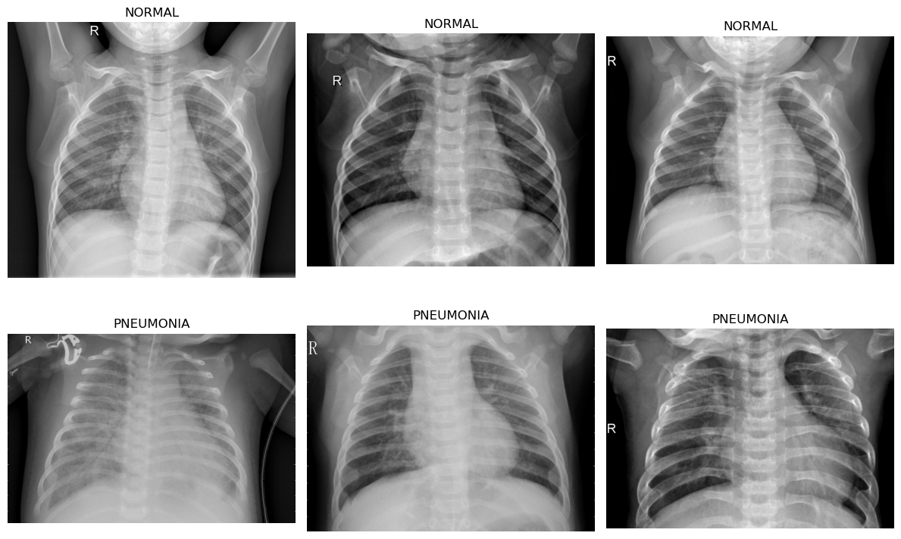
Figure 1. Sample training images — NORMAL (top row) vs. PNEUMONIA (bottom row) chest X-rays.

4. Methodology

4.1 Environment Setup
The environment was set up with pandas, numpy, matplotlib, seaborn, scikit-learn, and TensorFlow 2.21.0. GPU acceleration was unavailable, as native Windows builds of TensorFlow 2.11+ no longer support GPU training without WSL2 or DirectML; training therefore ran on CPU.

4.2 Data Verification and Inspection
The dataset path was verified programmatically, and the number of images per class and per split was counted to confirm the class distribution shown in Section 3. Sample images from both classes were displayed to visually confirm the data was loading correctly, and a handful of images were checked for dimensions and color mode.

4.3 Preprocessing
Images were loaded using tf.keras.utils.image_dataset_from_directory, resized to 150x150 pixels, and grouped into batches of 32. Pixel values were rescaled from the [0, 255] range to [0, 1] using a Rescaling layer. This produced batches of shape (32, 150, 150, 3) ready for the CNN.

4.4 Model Architecture
A sequential CNN was built with three convolutional blocks, each pairing a Conv2D layer with a MaxPooling2D layer, followed by a flattening layer, a fully connected (Dense) layer of 128 units, and a final sigmoid output neuron for binary classification:
- Conv2D(32, 3x3, ReLU) -> MaxPooling2D(2x2)
- Conv2D(64, 3x3, ReLU) -> MaxPooling2D(2x2)
- Conv2D(128, 3x3, ReLU) -> MaxPooling2D(2x2)
- Flatten -> Dense(128, ReLU) -> Dense(1, Sigmoid)
The model was compiled with the Adam optimizer, binary crossentropy loss, and accuracy as the tracked metric, resulting in approximately 14.5 million total parameters.

4.5 Training
The model was trained for 10 epochs on the training set, with the validation set monitored after each epoch. Training results are summarized below:
Epoch | Train Acc | Train Loss | Val Acc | Val Loss
1 | 0.9988 | 0.0050 | 0.9375 | 0.1724
2 | 0.9954 | 0.0117 | 0.8125 | 0.8218
3 | 0.9933 | 0.0176 | 0.8750 | 0.2222
4 | 0.9919 | 0.0279 | 0.8125 | 0.2416
5 | 0.9967 | 0.0102 | 0.9375 | 0.0637
6 | 0.9988 | 0.0055 | 0.8750 | 0.4910
7 | 0.9965 | 0.0081 | 0.9375 | 0.3183
8 | 0.9996 | 0.0015 | 0.9375 | 0.1765
9 | 0.9998 | 0.0010 | 0.9375 | 0.2745
10 | 1.0000 | 0.0001 | 0.9375 | 0.3908

Training accuracy climbed rapidly to near 100% within the first few epochs, while validation accuracy fluctuated between 81% and 94% without a clear improving trend. This pattern, alongside a rising and unstable validation loss in several epochs, is a classic signature of overfitting.

5. Evaluation Results

5.1 Test Set Performance
On the held-out test set of 624 images, the model achieved:
- Test accuracy: 74.68%
- Test loss: 4.77
This is substantially lower than the ~100% training accuracy and ~93.75% final validation accuracy, confirming that the model does not generalize well to unseen data.

5.2 Confusion Matrix
 | Predicted NORMAL | Predicted PNEUMONIA
Actual NORMAL | 78 | 156
Actual PNEUMONIA | 2 | 388

The confusion matrix shows the model correctly identified 388 of 390 PNEUMONIA cases but only 78 of 234 NORMAL cases, misclassifying 156 NORMAL X-rays as PNEUMONIA.
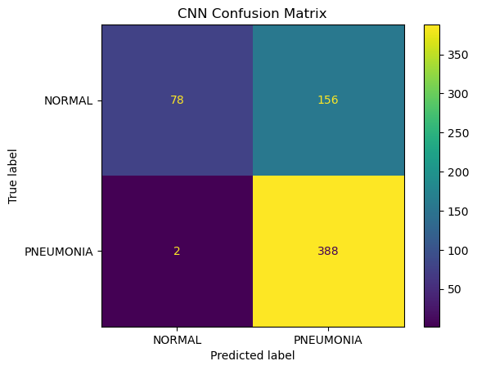
Figure 2. Confusion matrix on the test set (624 images).

5.3 Classification Report
Class | Precision | Recall | F1-score
NORMAL | 0.97 | 0.33 | 0.50
PNEUMONIA | 0.71 | 0.99 | 0.83

Overall test accuracy was 75%, with a macro-average F1-score of 0.66 and a weighted-average F1-score of 0.71. The model is strongly biased toward predicting PNEUMONIA: recall for PNEUMONIA is 0.99, but recall for NORMAL is only 0.33. This means the model correctly flags nearly all pneumonia cases but incorrectly labels most normal X-rays as pneumonia, which is likely a direct consequence of the class imbalance in the training data (1,341 NORMAL vs. 3,875 PNEUMONIA images).

6. Prediction on New Images
The trained model was also tested on an external chest X-ray image outside the original dataset. The image was resized to 150x150, normalized, and passed through the model, which classified it as PNEUMONIA with 100% confidence. The full pipeline (load image, preprocess, predict, display result) worked as intended, demonstrating the model is usable for single-image inference in addition to batch evaluation.
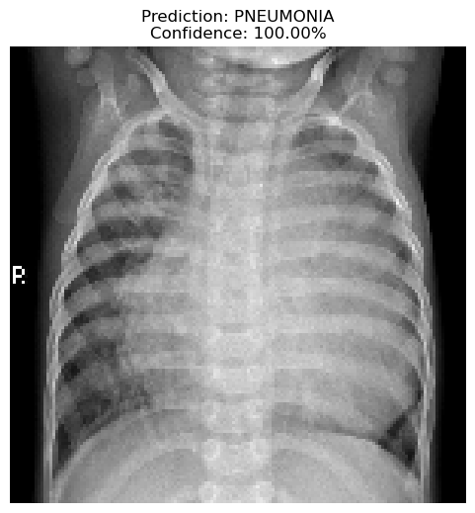
Figure 3. Prediction on a new external chest X-ray image (xray1.jpeg).
Note: two additional in-notebook prediction visualizations (single test-set image checks) rendered as solid black figures due to an image display bug — the normalized [0, 1] pixel array was cast directly to 8-bit integers with astype("uint8") before calling imshow, which rounds nearly all values down to 0. The underlying predictions were still computed correctly; only the plotted image was affected. This can be fixed by either not casting to uint8 (imshow accepts float arrays in [0, 1] directly) or by multiplying by 255 before casting.

7. Discussion
The results reveal two main issues that limit the model's real-world reliability:
- Overfitting: near-perfect training accuracy paired with a much lower and unstable test/validation accuracy indicates the model memorized training examples rather than learning generalizable patterns.
- Class imbalance bias: with almost three times as many PNEUMONIA training images as NORMAL, the model learned to favor predicting PNEUMONIA, driving recall for NORMAL cases down to 33%. In a medical screening context, this specific failure mode (missing true NORMAL cases) is less dangerous than missing PNEUMONIA cases, but the low NORMAL recall would still cause a high rate of unnecessary follow-up for healthy patients.

8. Recommendations for Future Work
- Add Dropout layers (e.g., 0.5) after the dense layer to reduce overfitting.
- Apply data augmentation (random flips, rotations, zoom) to increase training data diversity.
- Address class imbalance using class weighting or resampling techniques.
- Expand the validation set beyond 16 images for a more reliable training signal.
- Use an EarlyStopping callback based on validation loss instead of a fixed epoch count.
- Save the model in the native Keras format (.keras) instead of the legacy HDF5 (.h5) format.
- Explore transfer learning with a pretrained backbone (e.g., ResNet, EfficientNet) to improve generalization with limited data.

9. Conclusion
This project successfully implemented a full CNN-based pipeline for classifying chest X-rays as NORMAL or PNEUMONIA, from data loading through model training, evaluation, and single-image prediction. While the model achieves strong recall for pneumonia detection (99%), its overall test accuracy of 74.68% and low recall for normal cases (33%) show clear signs of overfitting and class-imbalance bias. Addressing these issues through dropout, augmentation, and balanced training would be the natural next step toward a more robust and clinically useful model.

